E-WASTE RECYCLING DATABASE
A MINI-PROJECT REPORT
Submitted by

SRI RAMKANNA M 241801275
SIDDHARTH RADHAKRISHNAN 241801287

in partial fulfillment of the award of the degree
of
BACHELOR OF ENGINEERING
IN
COMPUTER SCIENCE AND ENGINEERING

RAJALAKSHMI ENGINEERING COLLEGE, CHENNAI
An Autonomous Institute
CHENNAI
NOVEMBER 2025

BONAFIDE CERTIFICATE
Certified that this project “LIBRARY MANAGEMENT SYSTEM” is the bonafide work of “SRI RAMKANNA M, SIDDHARTH RADHAKRISHNAN” who carried out the project work under my supervision.

SIGNATURE
R. SAVITHRI
ASSISTANT PROFESSOR SG
Dept. of Artificial Intelligence and Data Science
Rajalakshmi Engineering College
Chennai

This mini project report is submitted for the viva voce examination to be held on __________

INTERNAL EXAMINER EXTERNAL EXAMINER

ABSTRACT

The Library Management System is designed to automate and streamline the day-to-day operations of a library. The system enables efficient handling of book records, member details, issue and return transactions, and fine management. By computerizing these processes, the system eliminates manual work and reduces human error.
The main objective of this project is to build an interactive and reliable platform where administrators can manage books, students can view and borrow available books, and all transactions are securely recorded. This project helps improve accessibility, data consistency, and overall efficiency in maintaining a modern digital library environment.
.

ACKNOWLEDGEMENT

We express our sincere thanks to our beloved and honorable chairman MR. S. MEGANATHAN and the chairperson DR. M.THANGAM MEGANATHAN for their timely support and encouragement.
We are greatly indebted to our respected and honorable principal
Dr. S.N. MURUGESAN for his able support and guidance.
No words of gratitude will suffice for the unquestioning support extended to us by our Head Of The Department Dr. J.M. GNANASEKARfor being ever supporting force during our project work
We also extend our sincere and hearty thanks to our internal guide Dr. R. SAVITHRI , for her valuable guidance and motivation during the completion of this project.
Our sincere thanks to our family members, friends and other staff members of computer science engineering.
1. SRI RAMKANNA M
2. SIDDHARTH RADHAKRISHNAN

TABLE OF CONTENTS

CHAPTER NO.TITLE PAGE NO
ABSTRACT iv

1 INTRODUCTION 1
1.1 INTRODUCTION 8
1.2 SCOPE OF THE WORK 8
1.3 PROBLEM STATEMENT 8
1.4 AIM AND OBJECTIVES OF THE PROJECT 8
2 SYSTEM SPECIFICATIONS 9
2.1 HARDWARE SPECIFICATION 9
2.2 SOFTWARE SPECIFICATIONS 9
3 MODULE DESCRIPTION 10
4 CODING 11
5 SCREENSHOTS 16
6 CONCLUSION AND FUTURE ENHANCEMENT 18
7 REFERENCES 19

LIST of figures
FIGURE NO. | TITLE | PAGE NO.
5.1 | HOMEPAGE | 15
5.2 | ADMIN DASHBOARD | 15
5.3 | BOOK ISSUE PAGE | 16
5.4 | RETURN LOG | 16
5.5 | MEMBER REGISTRATION | 17
5.6 | DATABASE TABLES | 17

CHAPTER 1
INTRODUCTION
CHAPTER 1
INTRODUCTION
1.1 INTRODUCTION
The Library Management System helps manage and maintain the complete database of a library efficiently. It allows librarians and users to view, issue, return, and update book records digitally. This system eliminates manual record-keeping, minimizes human errors, and improves user experience by providing a simple, web-based interface for book management and borrowing.
1.2 SCOPE OF THE WORK
The system aims to automate traditional library operations such as adding new books, registering members, issuing and returning books, and maintaining fine records. It also provides search functionality to locate books quickly and view availability status.
1.3 PROBLEM STATEMENT
Manual management of library books and student records often leads to delays, data loss, and inefficiency. Tracking issued books, calculating fines, and updating records manually consume significant time and resources.
1.4 AIM AND OBJECTIVES OF THE PROJECT
Aim: To design and implement a web-based Library Management System that efficiently manages all library-related activities.
Objectives:
- To create a centralized system for managing books, students, and transactions.
- To automate the issue and return process using a secure login..
CHAPTER 2
SYSTEM SPECIFICATIONS
2.1 HARDWARE SPECIFICATIONS
Processor | : | Intel i5
Memory Size | : | 4GB (Minimum)
HDD | : | 250 GB (Minimum)

2.2 SOFTWARE SPECIFICATIONS
Operating System | : | WINDOWS 10
Front – End | : | HTML, CSS, JavaScript
Back - End | : | MySqlDatabase
Language | : | Java (for database operations)
Tools Used | : | XAMPP Server, Eclipse IDE, PowerPoint for documentation

CHAPTER 3
MODULE DESCRIPTION

The Library Management System consists of two main modules: Administrator Module and User Module.
1. Administrator Module
- Can add, edit, or delete books and member records.
- Can issue or return books.
- Can view transaction logs and overdue reports.
2. User Module
- Can view available books and their details.
- Can request to borrow or return books.
- Can check due dates and fine details.
CHAPTER 4
SAMPLE CODING
SQL:
-- 1. Books Table
CREATE TABLE Books (
ISBN CHAR(13) PRIMARY KEY,
Title VARCHAR(100) NOT NULL,
Author VARCHAR(100) NOT NULL,
Publisher_Name VARCHAR(100),
Copies_Total INT DEFAULT 1,
Copies_Available INT DEFAULT 1
);

-- 2. Members Table (Students/Users)
CREATE TABLE Members (
Member_ID INT PRIMARY KEY AUTO_INCREMENT,
Name VARCHAR(100) NOT NULL,
Email VARCHAR(100) UNIQUE NOT NULL,
Password_Hash CHAR(60) NOT NULL -- Store password securely!
);

-- 3. Borrowing Records (Transactions)
CREATE TABLE Borrowing_Records (
Loan_ID INT PRIMARY KEY AUTO_INCREMENT,
ISBN CHAR(13) NOT NULL,
Member_ID INT NOT NULL,
Issue_Date DATE NOT NULL,
Due_Date DATE NOT NULL,
Return_Date DATE, -- NULL if not returned
Fine_Amount DECIMAL(5, 2) DEFAULT 0.00,
FOREIGN KEY (ISBN) REFERENCES Books(ISBN),
FOREIGN KEY (Member_ID) REFERENCES Members(Member_ID)
);

JAVA:
package com.lms.util;

import java.sql.Connection;
import java.sql.DriverManager;
import java.sql.SQLException;

public class DBConnection {
private static final String URL = "jdbc:mysql://localhost:3306/library_db";
private static final String USER = "root"; // XAMPP default
private static final String PASSWORD = ""; // XAMPP default

public static Connection getConnection() throws SQLException {
try {
// Load the MySQL JDBC driver
Class.forName("com.mysql.cj.jdbc.Driver");
} catch (ClassNotFoundException e) {
e.printStackTrace();
throw new SQLException("MySQL Driver not found.");
}
return DriverManager.getConnection(URL, USER, PASSWORD);
}
}
package com.lms.dao;

import com.lms.util.DBConnection;
import java.sql.*;

public class BookDAO {
private static final String INSERT_BOOK =
"INSERT INTO books (isbn, title, author, total_copies, available_copies) VALUES (?, ?, ?, ?, ?)";

public boolean addBook(String isbn, String title, String author, int copies) {
try (Connection conn = DBConnection.getConnection();
PreparedStatement ps = conn.prepareStatement(INSERT_BOOK)) {

ps.setString(1, isbn);
ps.setString(2, title);
ps.setString(3, author);
ps.setInt(4, copies);
ps.setInt(5, copies); // available_copies = total_copies initially

int result = ps.executeUpdate();
return result > 0;
} catch (SQLException e) {
e.printStackTrace();
return false;
}
}

// **TODO:** Add methods like: getAllBooks(), updateBook(), deleteBook()
}

HTML:
<%@ page language="java" contentType="text/html; charset=UTF-8" pageEncoding="UTF-8"%>
<!DOCTYPE html>
<html>
<head>
<title>Librarian Dashboard</title>
<link rel="stylesheet" href="style.css">
</head>
<body>
<h2>Librarian Dashboard</h2>

<%
// Display message from servlet (Step 4.1)
String message = (String) request.getAttribute("message");
if (message != null) {
out.println("<p style='color: green;'>" + message + "</p>");
}
%>

<h3>Add New Book</h3>
<form action="AddBook" method="post">
<label>ISBN:</label><input type="text" name="isbn" required><br><br>
<label>Title:</label><input type="text" name="title" required><br><br>
<label>Author:</label><input type="text" name="author" required><br><br>
<label>Total Copies:</label><input type="number" name="copies" required><br><br>
<button type="submit">Add Book</button>
</form>

<p><a href="logout.jsp">Logout</a></p>
</body>
</html>

CHAPTER 5
SCREEN SHOTS

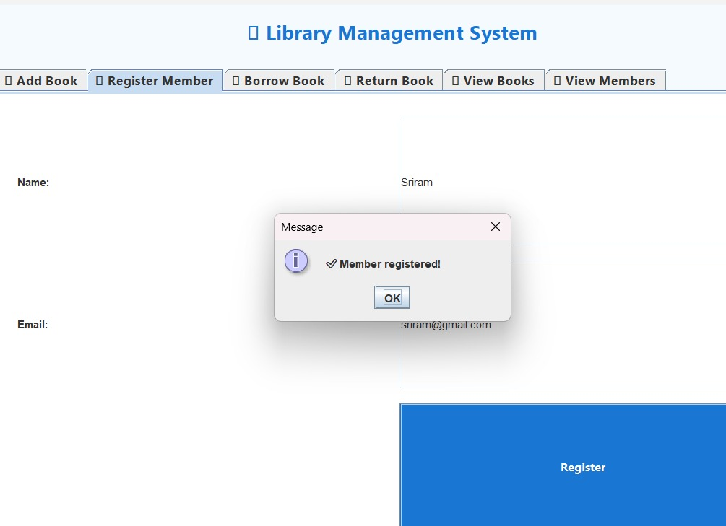

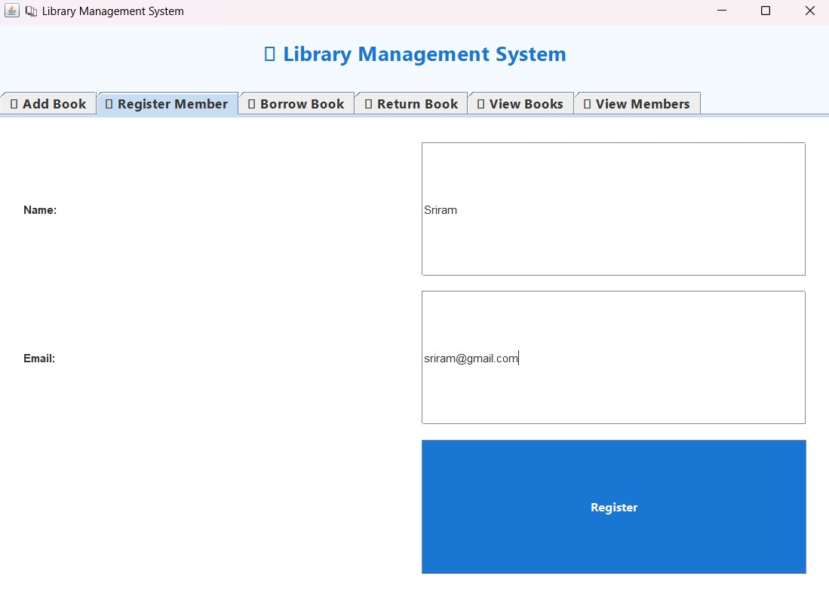
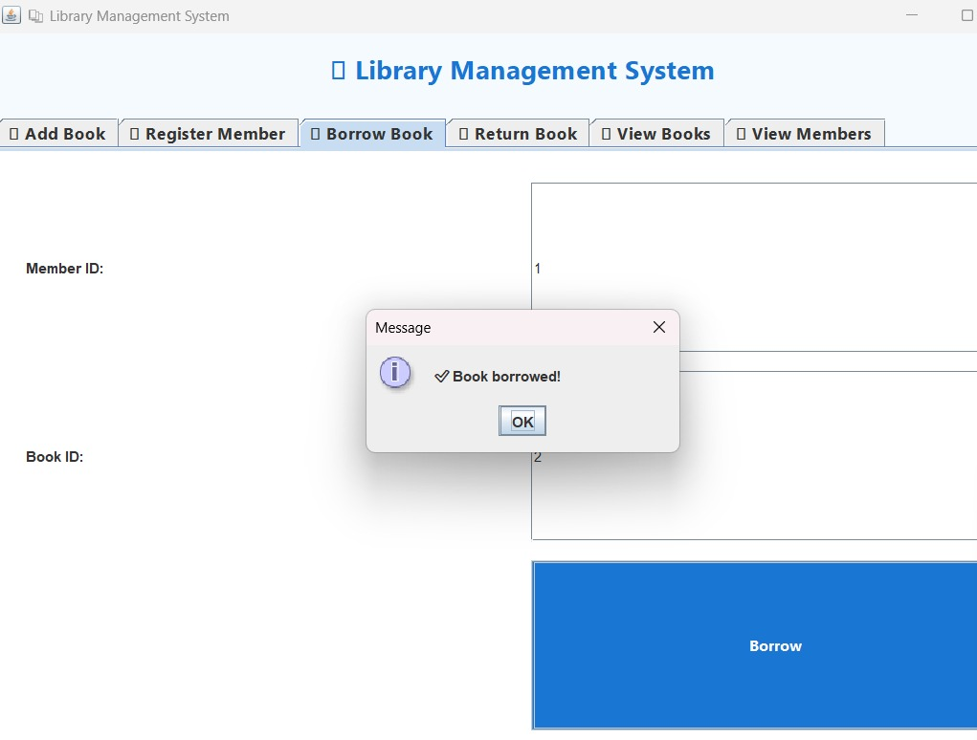

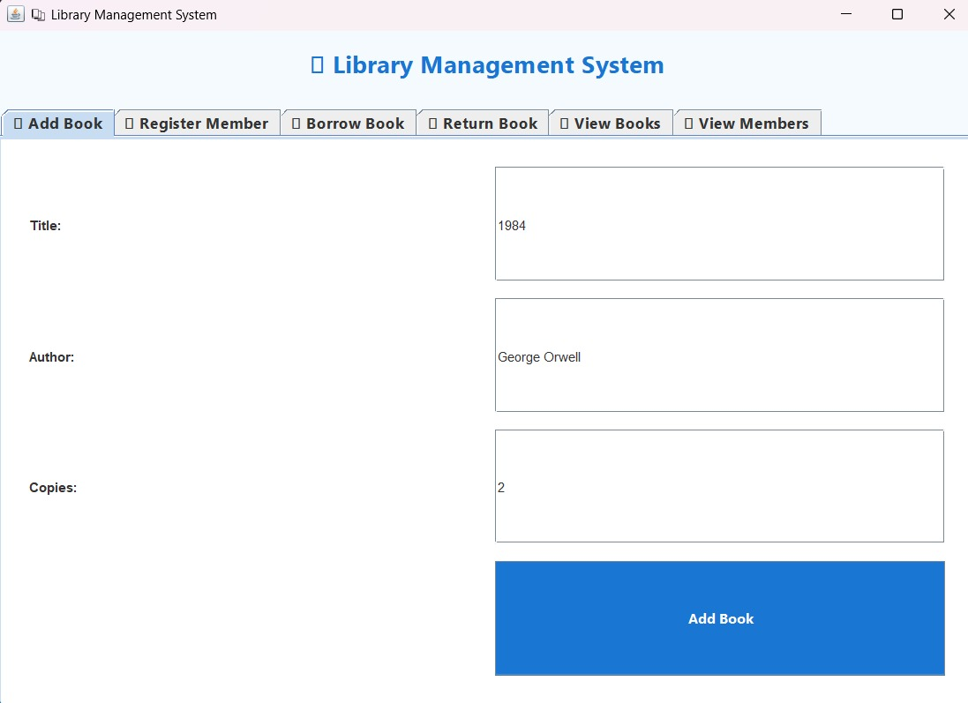
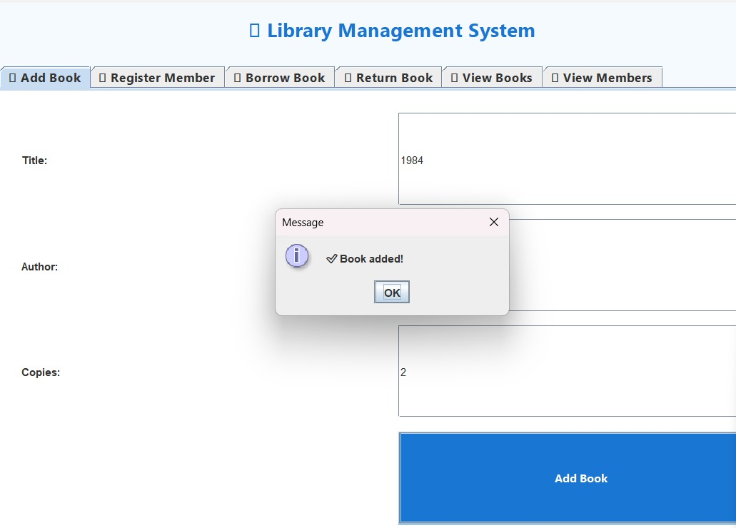

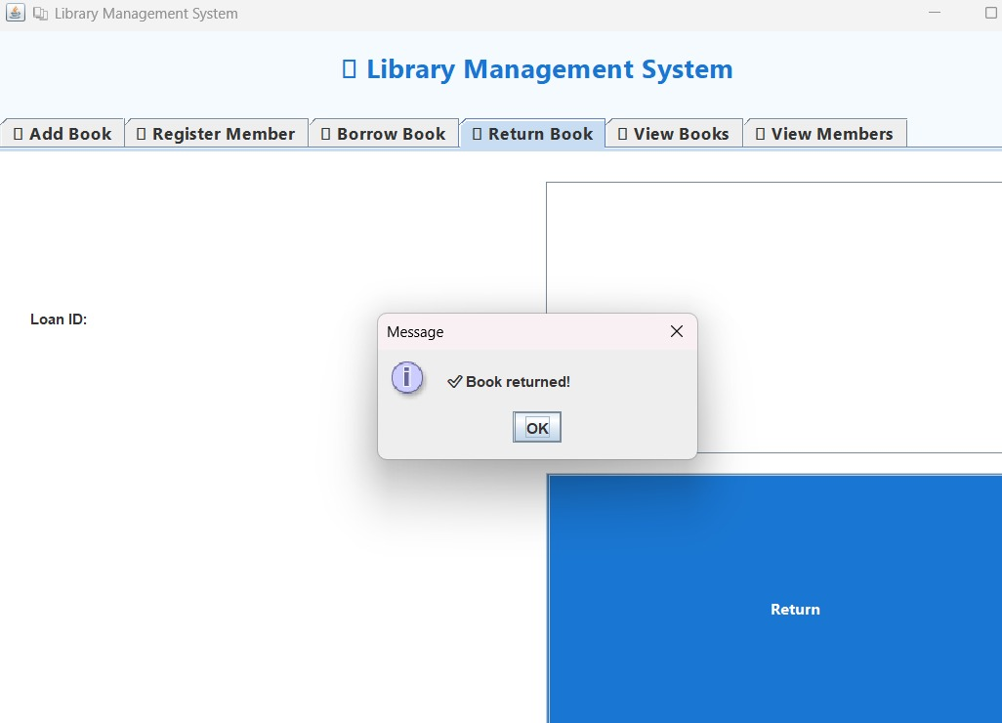

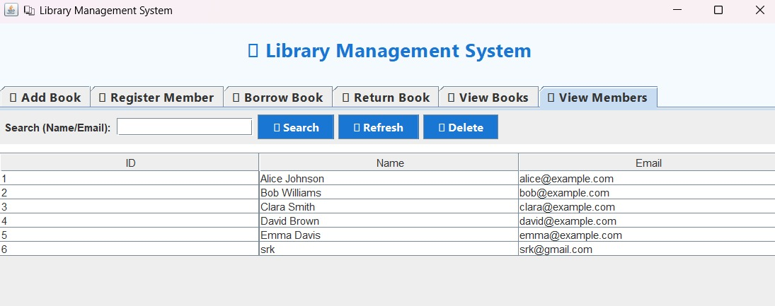

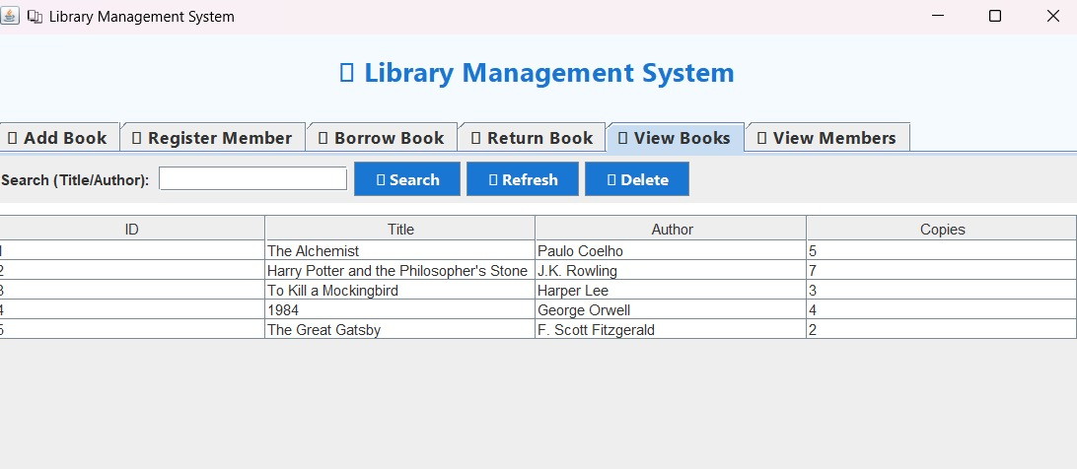

CHAPTER 6

CONCLUSION AND FUTURE ENHANCEMENT

The Library Management System provides a complete digital solution for handling library operations efficiently. It minimizes manual effort, ensures data accuracy, and provides an easy-to-use interface for both librarians and users.
Future Enhancements:
- Online book reservation and renewal system.
- Integration with barcode or RFID technology.
- Mobile application for user access.
- Cloud database for multi-branch synchronization.

REFERENCES

https://www.w3schools.com/java/
https://www.tutorialspoint.com/mysql/
https://www.w3schools.com/html/
https://www.geeksforgeeks.org/
https://www.oracle.com/java/

